5 Load Balancer & Auto Scaling
  - Configure Application Load Balancer
  - Attach Auto Scaling group
  - Scale based on CPU utiliza

-Create template and after that create auto scaling group and select here template which we have created.
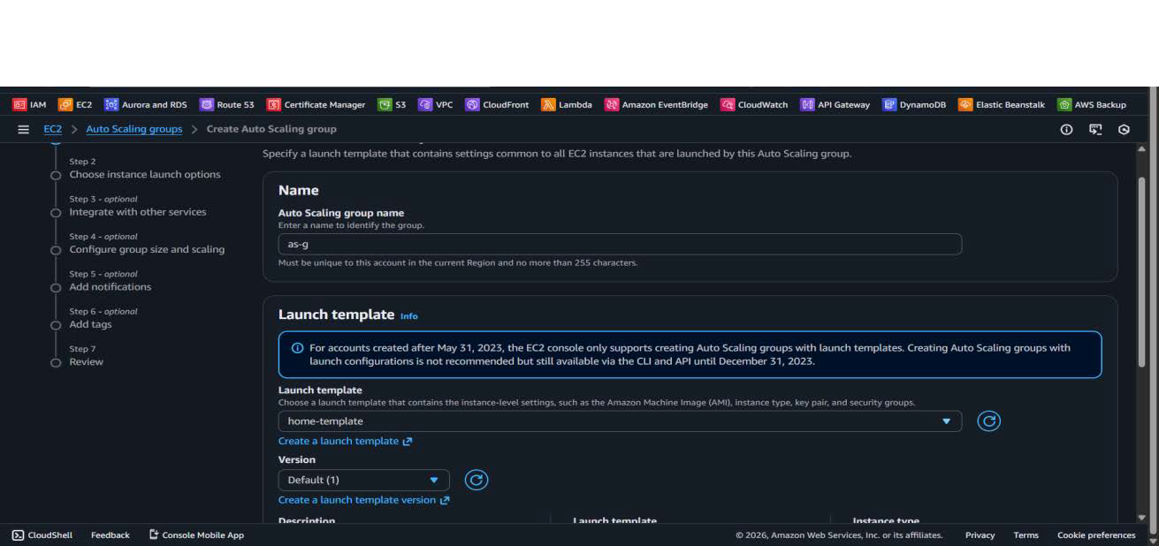
-Now set min, max and desired when we create auto scaling then automatically instance will create how we have mentioned in the desired instance will create how many is the desired capacity. When the CPU utilization is increases then instance will create.

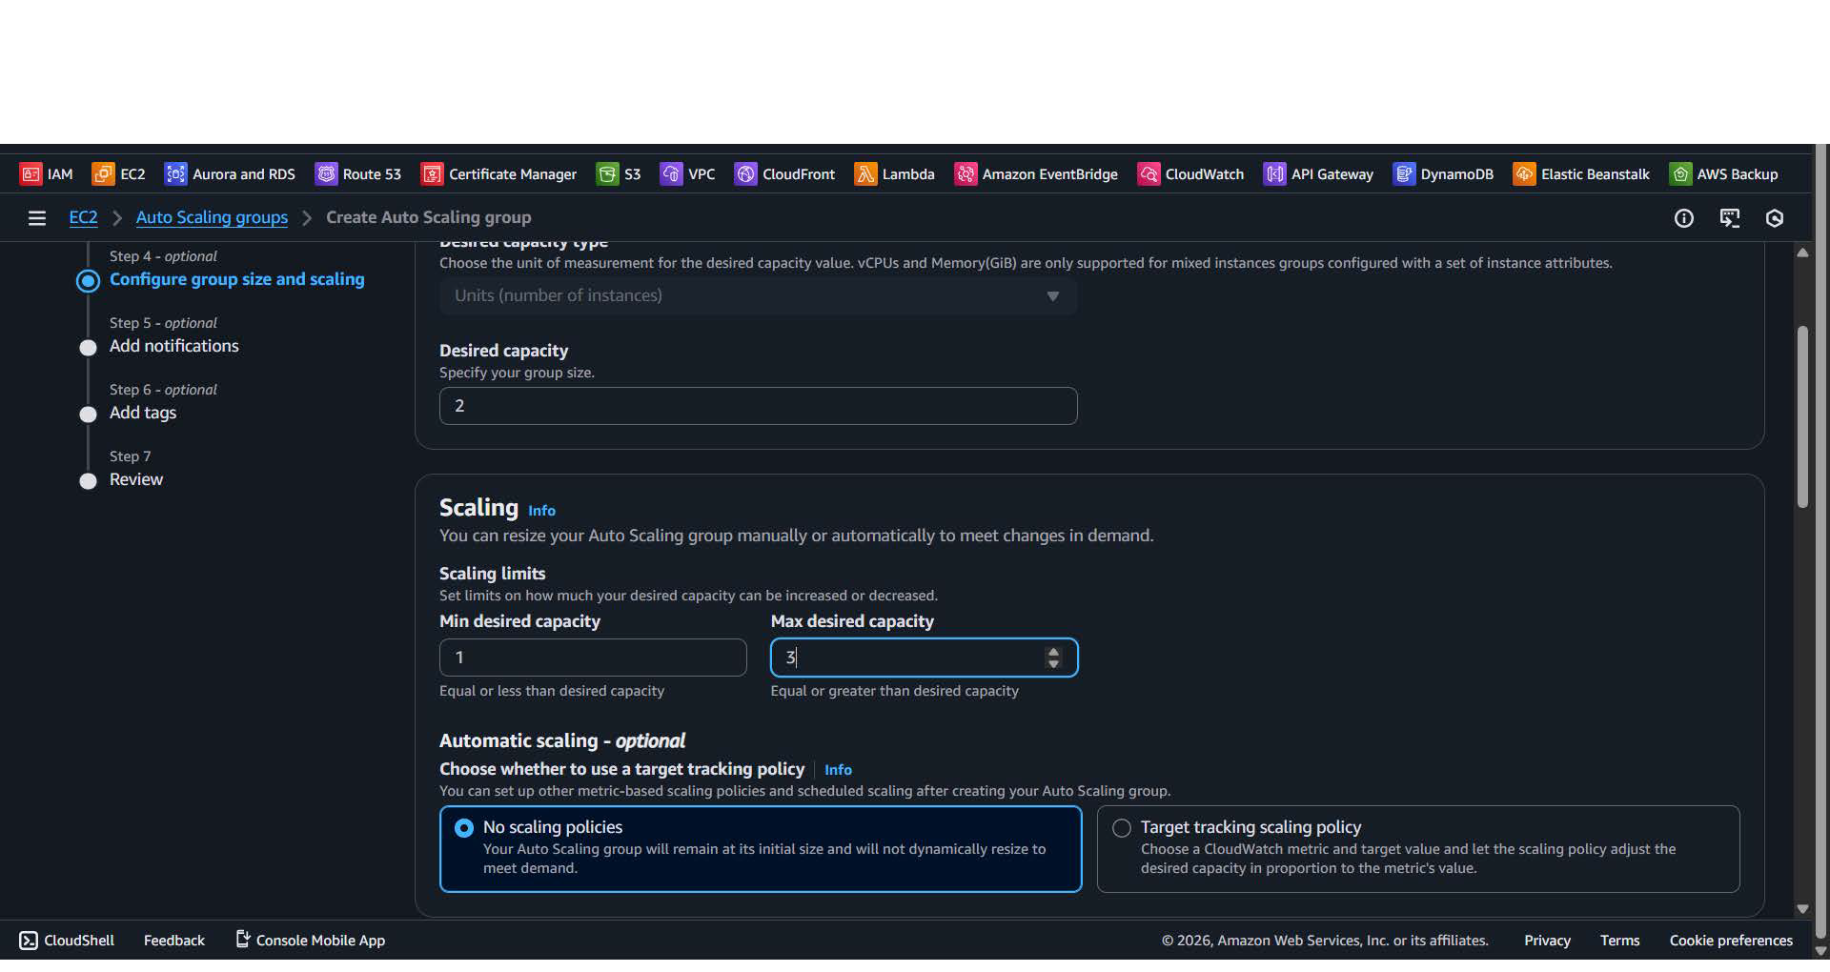

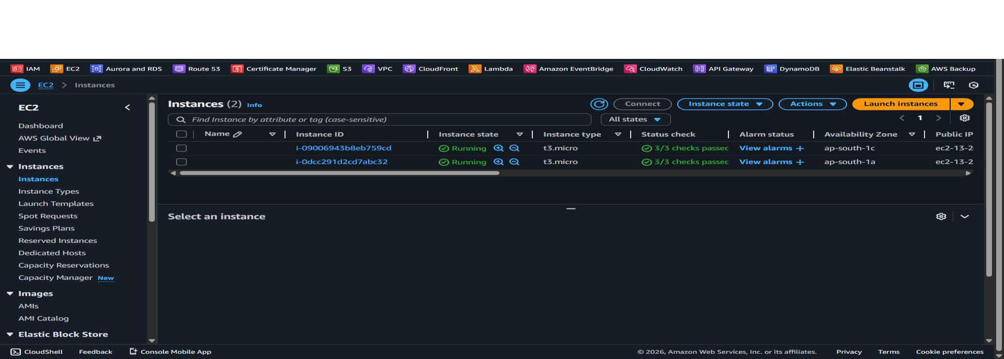
-We set desired capacity 2 that’s why here two instances are created automatically.
-When CPU utilization goes above 50 then Instance will create automatically.
Now create Target group for Load balancer and don’t add instances in the target group at the time of auto scaling and create application load balancer and add this attach this load balancer with auto scaling group.
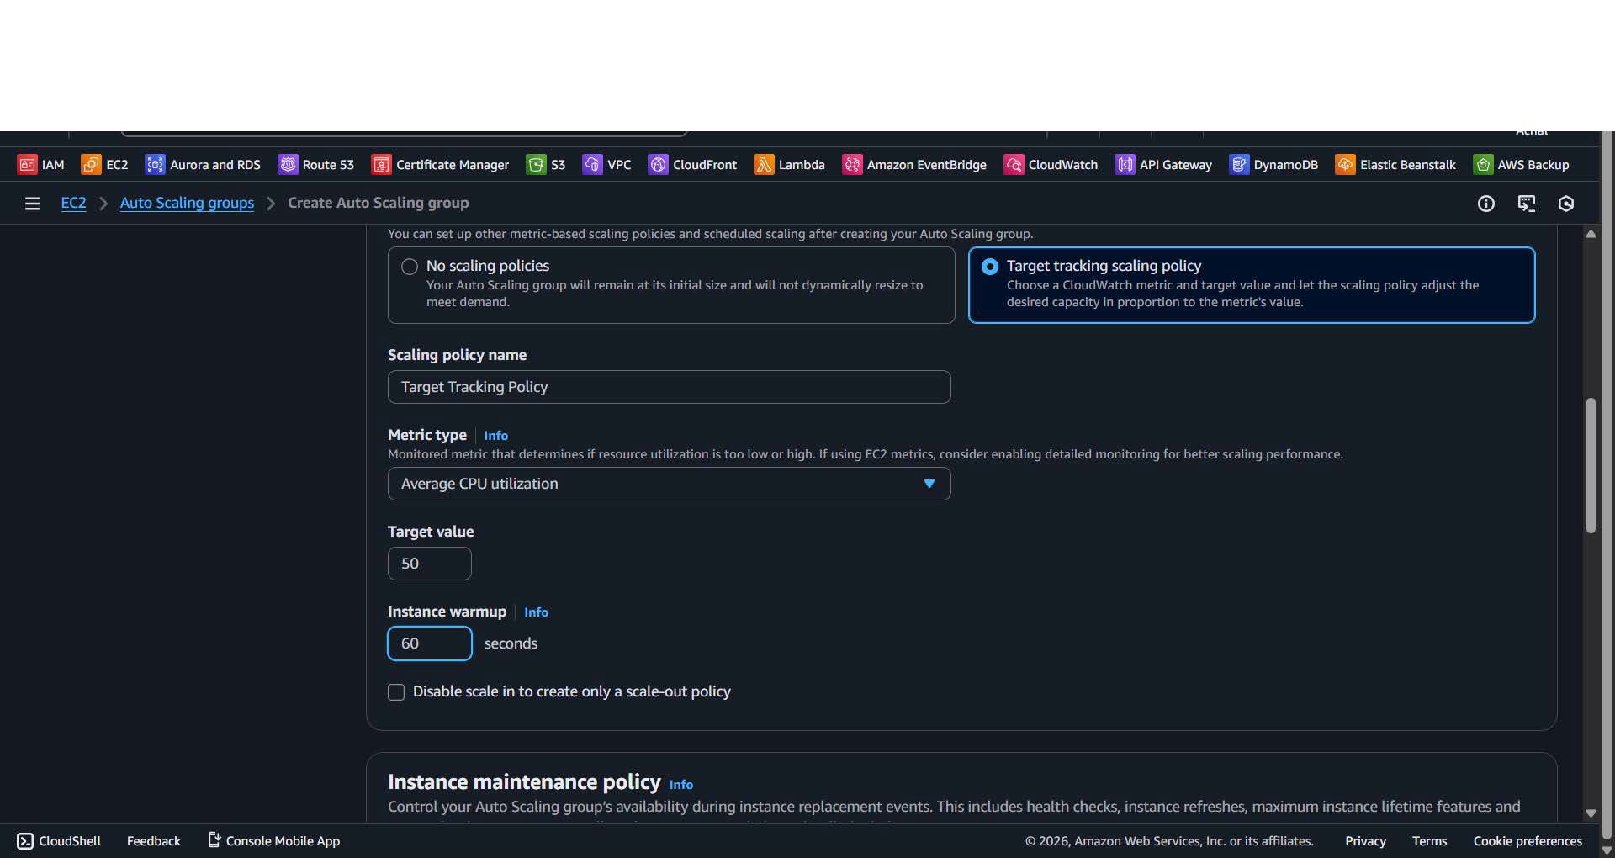
Now create Target group for Load balancer and don’t add instances in the target group at the time of auto scaling and create application load balancer and add this attach this load balancer with auto scaling group.

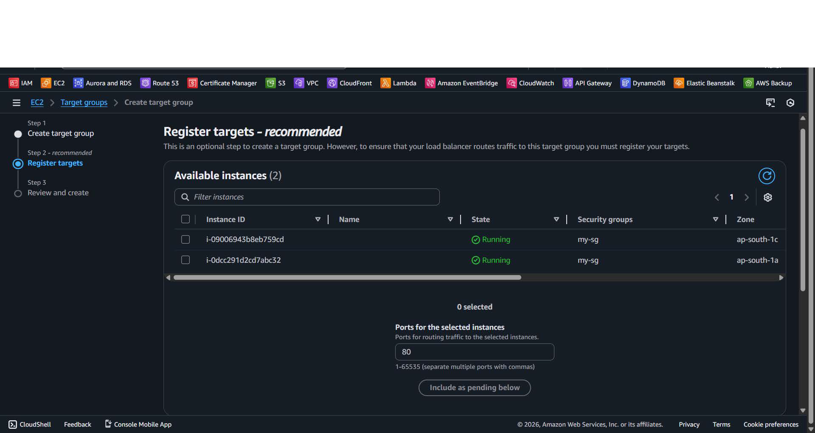
-Create Application load balancer for distribute the load and and Auto scaling for the launce ec2 instance when the CPU utilization is increases. And add target group and add rule for microservices.
